**Installation of Java and Eclipse:**

In order to develop Selenium RC or WebDriver scripts, users have to ensure that they have the initial configuration done. Setting up the environment involves the following steps.

* Download and Install Java
* Download and Configure Eclipse
* Configure FireBug and FirePath

**Download and Install Java**

We need to have JDK (Java Development Kit) installed in order to work with Selenium WebDriver/Selenium. Let us see how to download and install Java.

**Step 1**: Navigate to the URL:

http://www.oracle.com/technetwork/java/javase/downloads/index.html

**Step 2**: Go to "Downloads" section and select "JDK Download".

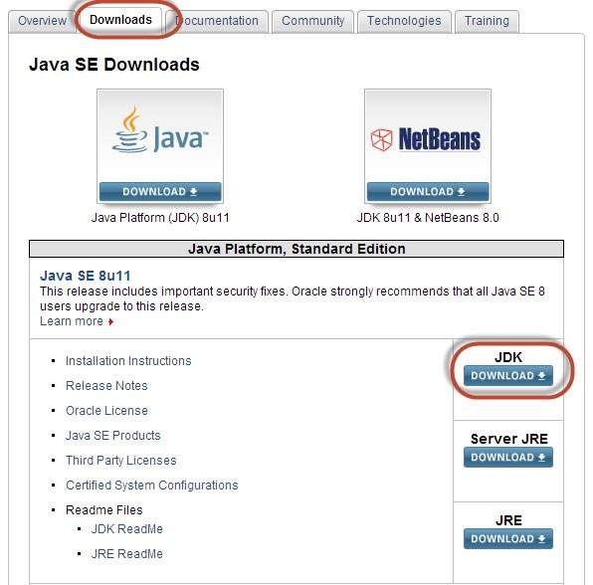

**Step 3**: Select "Accept License Agreement" radio button.

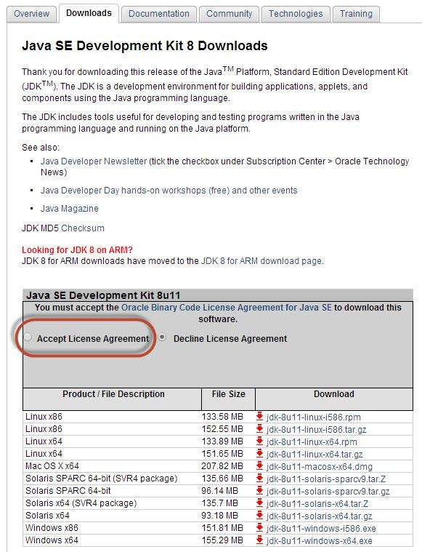

**Step 4** : Select the appropriate installation. In this case, it is 'Windows 7-64' bit. Click the appropriate link and save the .exe file to your disk.

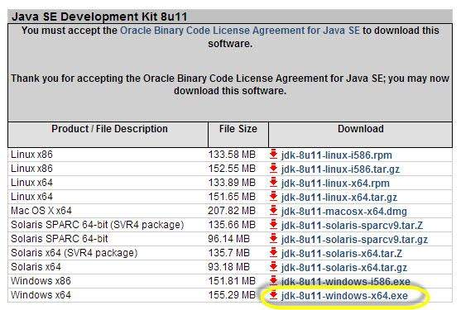

**Step 5**: Run the downloaded exe file to launch the Installer wizard. Click 'Next' to continue.

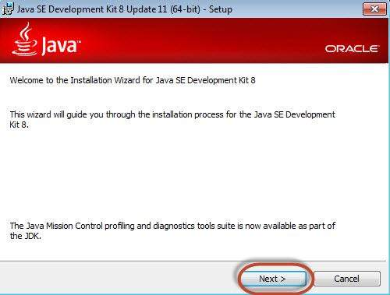

**Step 6**: Select the features and click 'Next'.

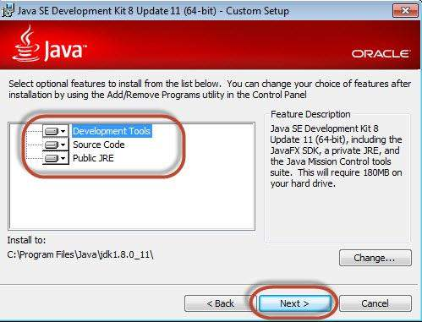

**Step 7**: The installer is extracted and its progress is shown in the wizard.

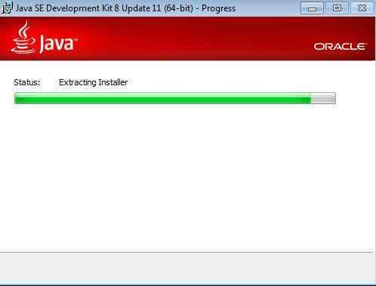

**Step 8**: The user can choose the install location and click 'Next'.

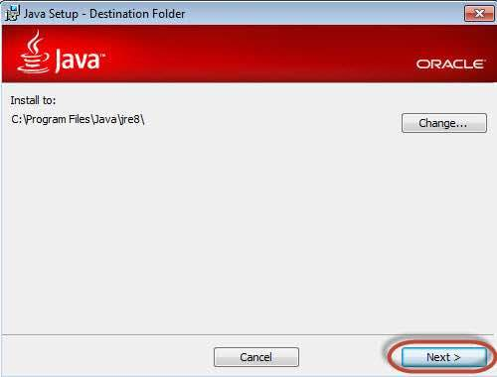

**Step 9**: The installer installs the JDK and new files are copied across.

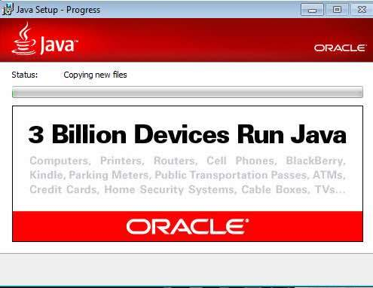

**Step 10**: The Installer installs successfully and displays the same to the user.

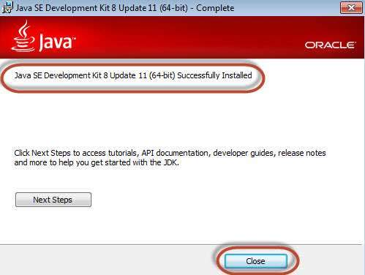

**Step 11**: To verify if the installation was successful, go to the command prompt and just type 'java' as a command. The output of the command is shown below. If the Java installation is unsuccessful or if it had NOT been installed, it would throw an "unknown command" error.

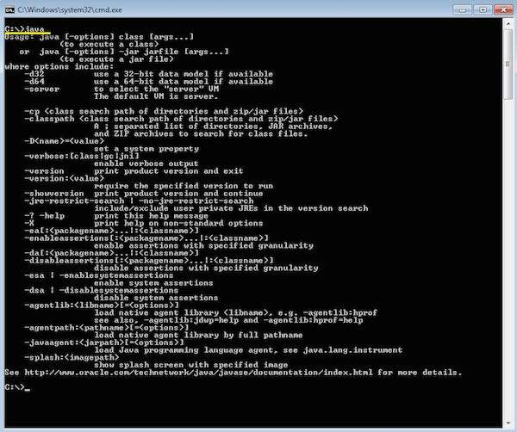

**Download and Configure Eclipse**

**Step 1**: Navigate to the URL: http://www.eclipse.org/downloads/ and download the appropriate file based on your OS architecture.

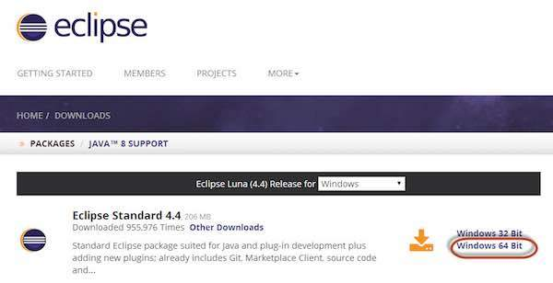

**Step 2** : Click the 'Download' button.

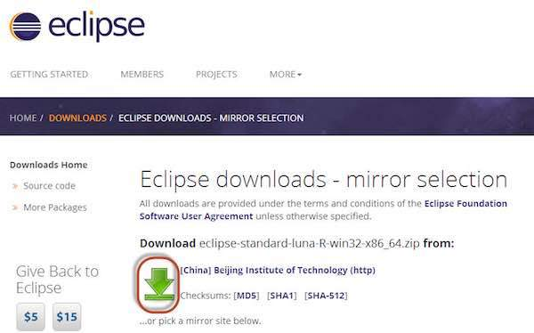

**Step 3**: The download would be in a Zipped format. Unzip the contents.

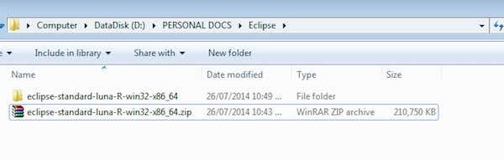

**Step 4**: Locate Eclipse.exe and double click on the file.

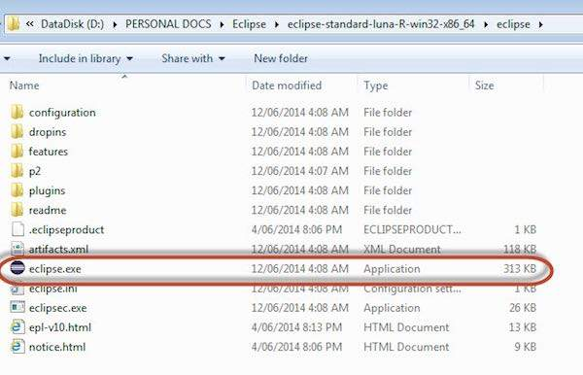

**Step 5**: To configure the workspace, select the location where the development has to take place.

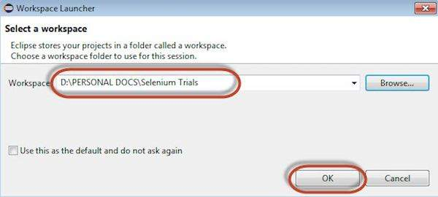

**Step 6**: The Eclipse window opens as shown below.

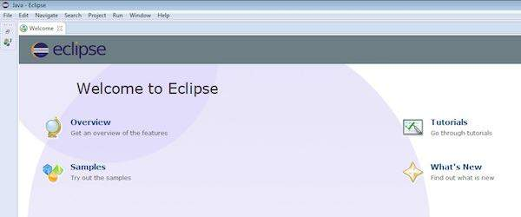

**Configure FireBug and FirePath**

To work with Selenium RC or WebDriver, we need to locate elements based on their XPath or ID or name, etc. In order to locate an element, we need tools/plug-in.

**Step 1** : Navigate to the URL : https://addons.mozilla.org/en-US/firefox/addon/firebug/ and download plug-in.

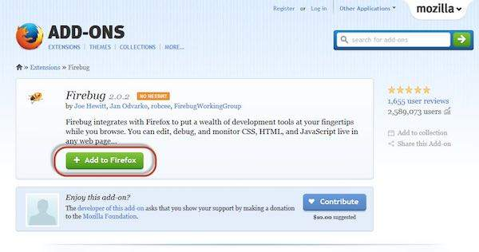

**Step 2**: The add-on installer is shown to the user and it is installed upon clicking the 'Install' button.

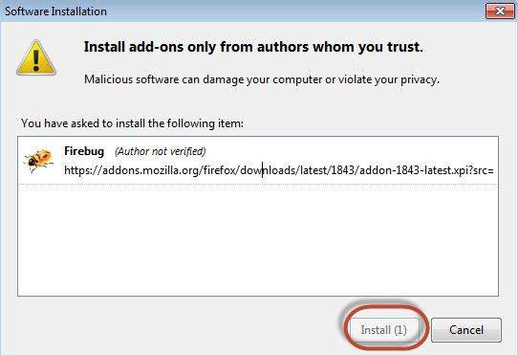

**Step 3**: After installing, we can launch the plug-in by navigating to "Web Developer" >> "Firebug".

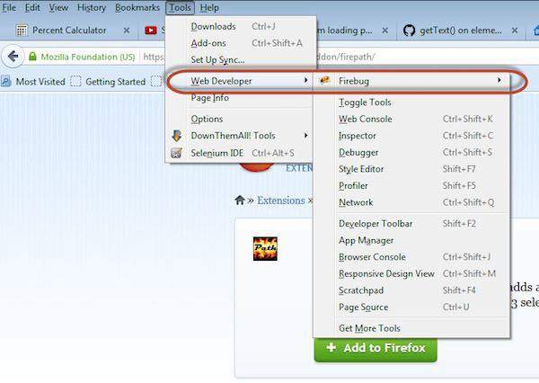

**Step 4** : FirePath, a plug-in that works within Firebug, helps users to grab the 'XPath' of an element. Install FirePath by navigating to "https://addons.mozilla.org/en-US/firefox/addon/firepath/"

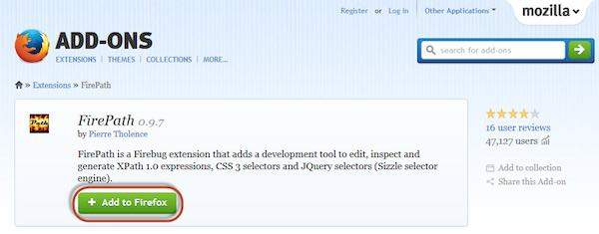

**Step 5**: The add-on installer is shown to the user and it is installed upon clicking the 'Install' button.

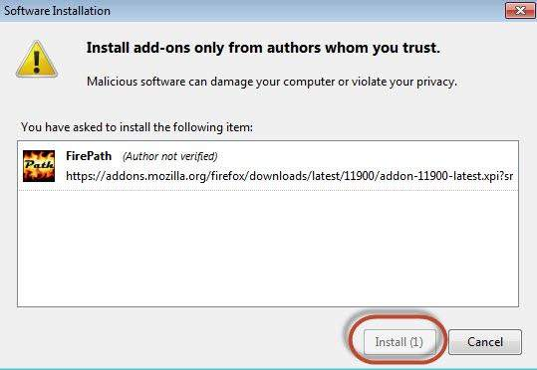

**Step 6** : Now launch "Firebug" by navigating to "Tools" >> "Web developer" >> "Firebug".

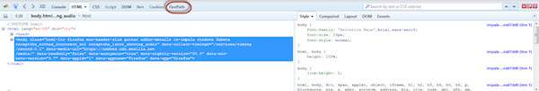

Example

Now let us understand how to use FireBug and FirePath with an example. For demonstration, we will use www.google.com and capture the properties of the text box of "google.com".

**Step 1**: First click on the arrow icon as highlighted in the following screenshot and drag it to the object for which we would like to capture the properties. The HTML/DOM of the object would be displayed as shown below. We are able to capture the 'ID' of the input text box with which we can interact.

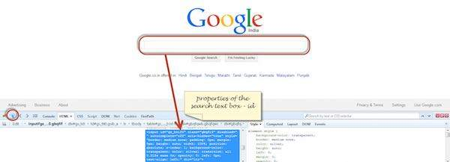

**Step 2**: To fetch the XPath of the object, go to 'FirePath' tab and perform the following steps.

* Click the Spy icon.
* Select the Control for which we would like to capture the XPath
* XPath of the selected control would be generated.

